**Installing Serial COMM Manager**

Run below mentioned file as administrator.

SerialCOMMangerSetup.MSI

**Usage:**

1. After successful installation look for SerialCOMManager in All programs to open the application as Administator.

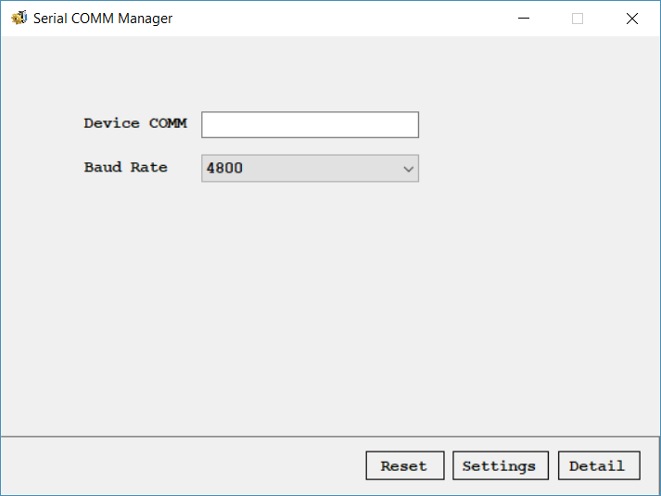

(figure no:1)

1. Once application window is started, enter proper device COMM connected in the system and choose corresponding baud rate to connect with device. On click of “Reset” option command “AT+RST” will be sent to device and on response from device “Device will be reset”.
2. On click of “Settings” option, below window will be displayed, also command “AT+GETCONFIG” will be issued to device to get already configured device settings.

**Format to be received: GETCONFIG:Device2,9600,Server,192.168.1.123,SSID,pass123,260**

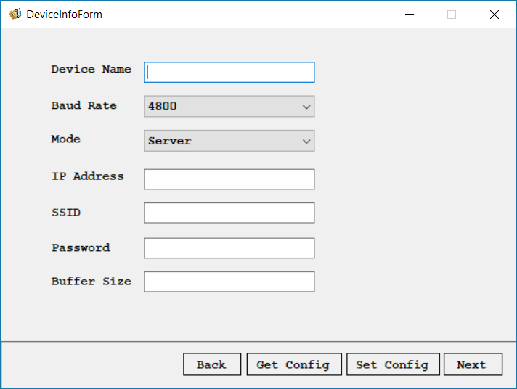

(figure no:2)

1. On click of “Get Config” option already configured device details will be fetched from device.
2. On click of “Set Config” option following command will be issued to device and on response from device “Device config will be setup”.

**Format will be send: AT+SETCONFIG:Device2,9600,Server,192.168.1.123,SSID,pass123,260**

1. On click of “Next” option below window will be displayed. This option will help to configure VCOM for the client devices connected.

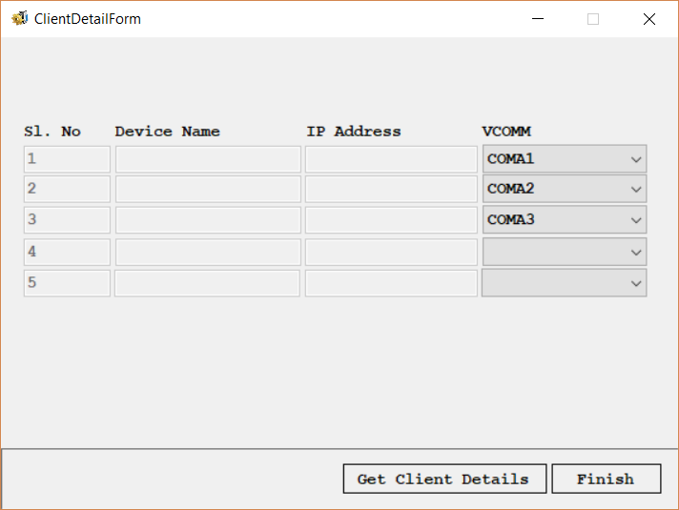

(figure no:3)

1. When above window displayed, command “AT+GETCLIENTDETAIL” will be issued to device to get connected client devices.

**Format to be received: GETCLIENTDETAIL:Device1-192.168.1.101,Device1-192.168.1.102,Device1-192.168.1.103**

1. Once connected devices details has been fetched, corresponding VCOM can be opted to devices.
2. On click of Finish all details will be saved, then a background process will be started which will listen to these VCOMs and share details between connected VCOMs and the Device.
3. On click of “Details” option from figure no .1, new window will be displayed which will show device configuration settings is READONLY mode.
4. On change of “Device Mode” option to “Client” in figure no.2, the option “Next” will change to “Finish” which will end the application by setting device to Client Mode.

Note: Exchanging of information between VCOM and Device COMM will be disconnected once this configuration application is started and after this configuration has finished, the service will be restarted.